1. NS Upload-Verify Trips-Edit trip-Click action button-Click Add line item-once data gets enter and click save button data gets saved but add line item pop up is not closed.

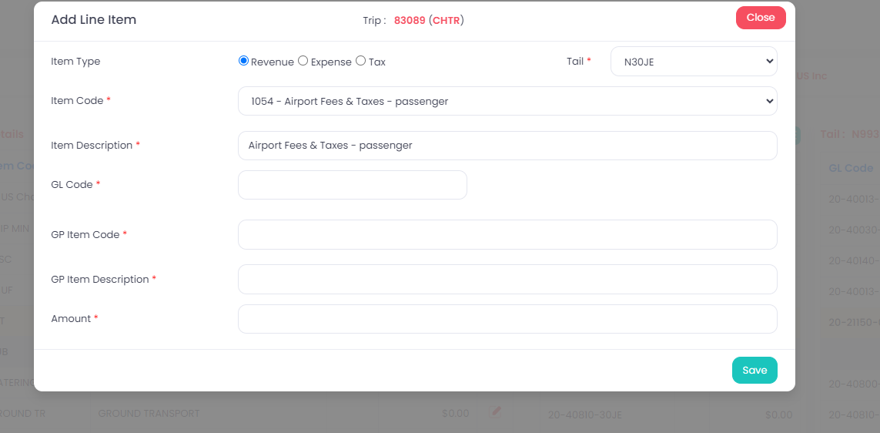

1. NS Upload-Net suite upload-click view buttton-in step 3, when no radio button is enabled “Notes field is showing. But, it shoould not show, Only yes radio button is selected then only notes field will enabled.

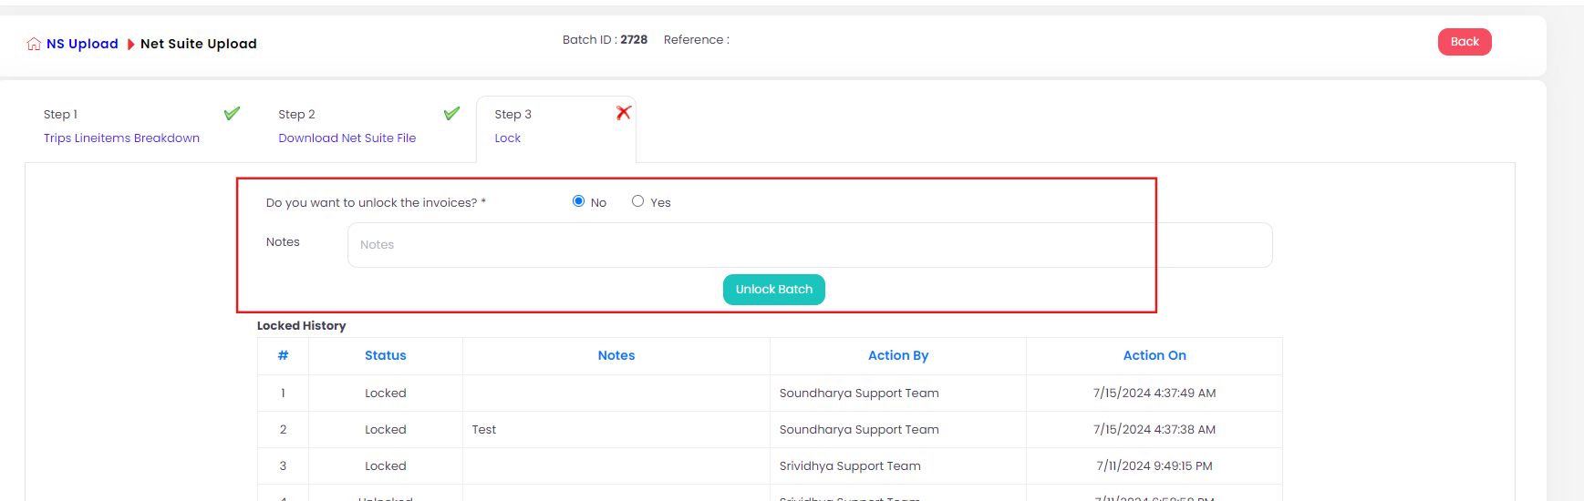

1. NS Upload-Net suite upload-click view buttton-in step 3, when no radio button is enabled and click unlock button it shows unlocked successfully message. But when “No” radio button is selected it should not unlock the invoice.



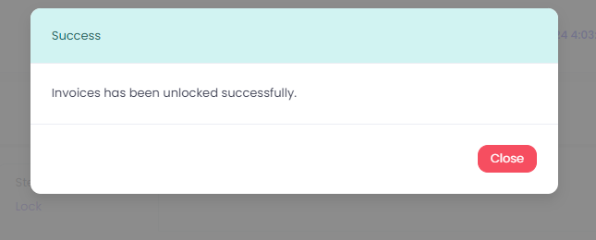

1. NS Upload-Net suite upload-click view buttton-in step 3, when batch is in locked status but user can able to modify the details in Step 2 and Step 3. User should not allowed to edit.

5.Forget Password page is not working.

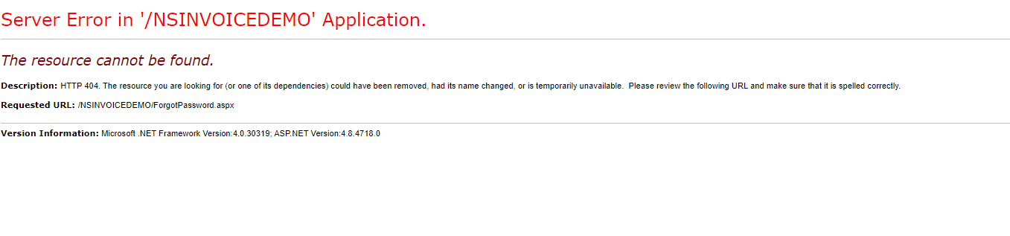

1. In NS Upload-International Tax Report-Heading of the webtable is not in center. It should be present in center

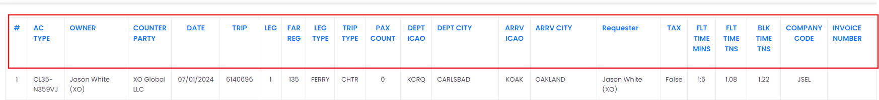

1. NS Upload-Trip Audit Report-For completed status in NS Status, in webtable “ALL” column is displayed checkbox, but it should show only for “Pending” option.

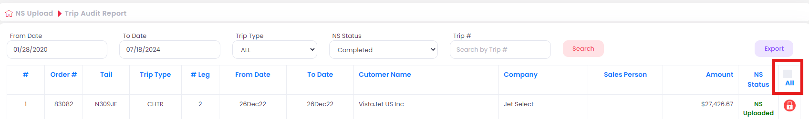

1. NS Upload-Change log Report-In Webtable, in amount column in amount value shows extra character at the end.

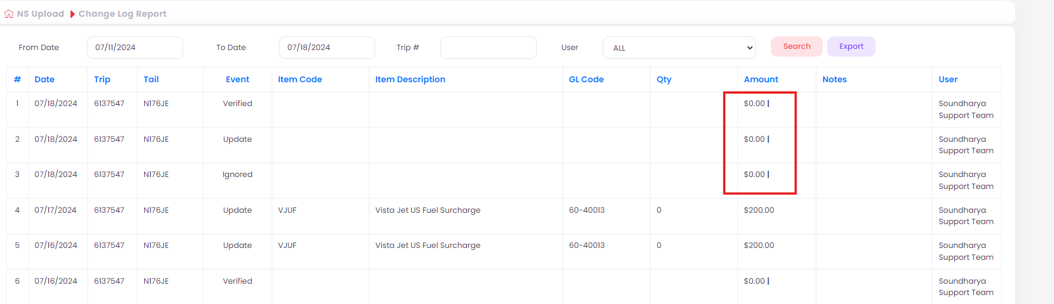

1. NS Upload-International Tax Report-After select 2019 date in from calendar page gets crashed.

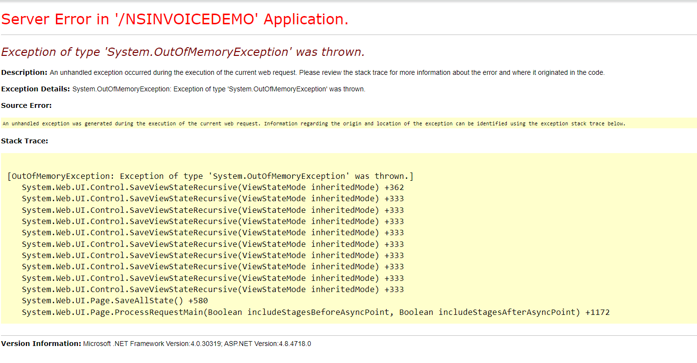

9.NS Upload-Audit Report-After select ignored option in trip status and click search button-Then click

Ignored trip setup-click add new-without enter any details and click save button, un releated mandatory message is displayed

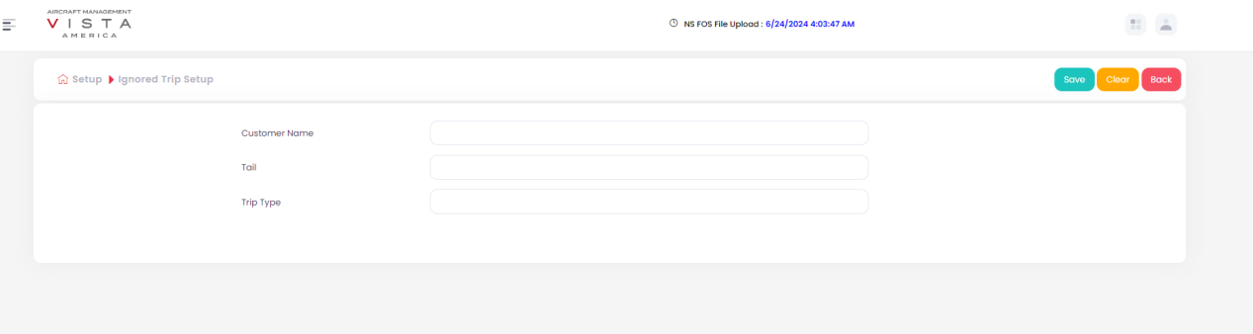

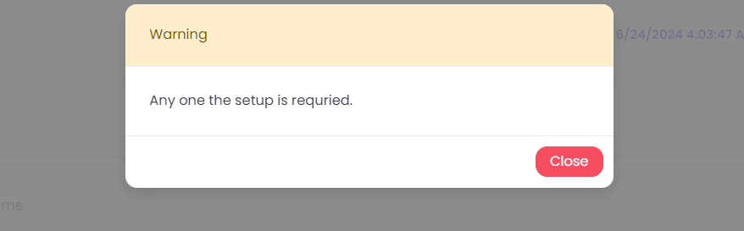

1. NS Upload-Audit Report-After enter valid details and click search button relevant details is not displayed.
2. NS Upload-Change Log Report-Search button is not working.

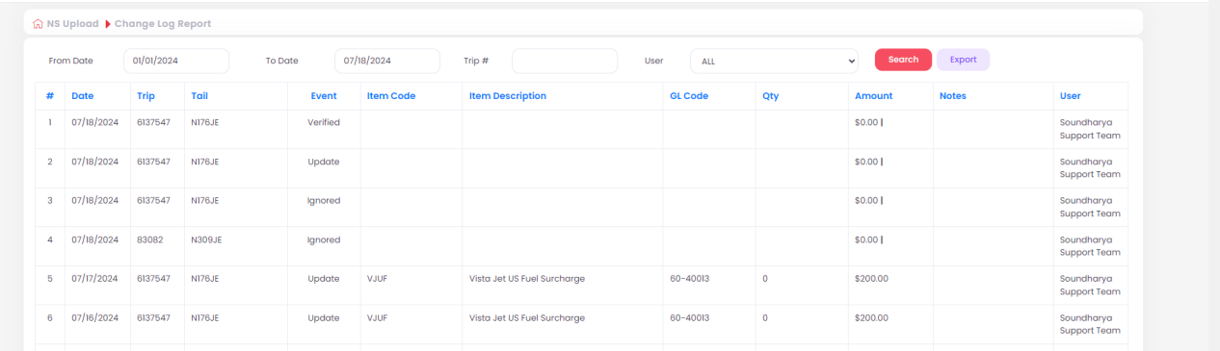

1. NS Upload-Verify trips-In the text verify trips need space between two words.

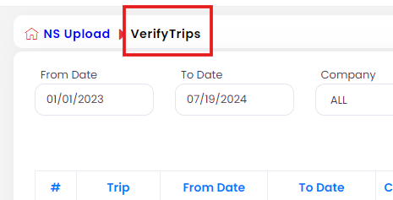

1. GP Upload 2.0-View trips 2.0-click Edit button-Click edit button in line item details-No mandatory symbol is displayed in revised amount in the table.

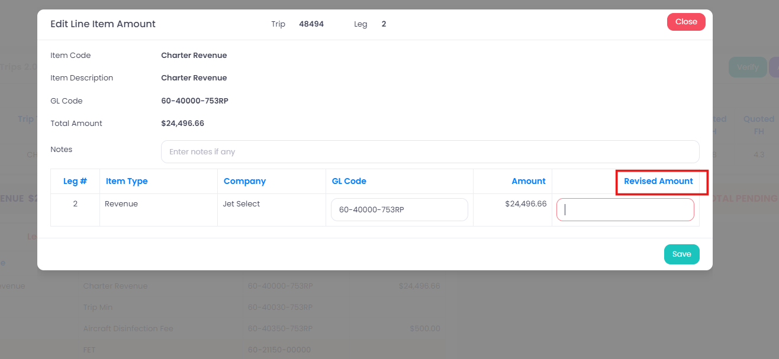

1. Setup-Fuel surcharge setup-Click Add new- Billing hour and date by radio button alignment is not proper.

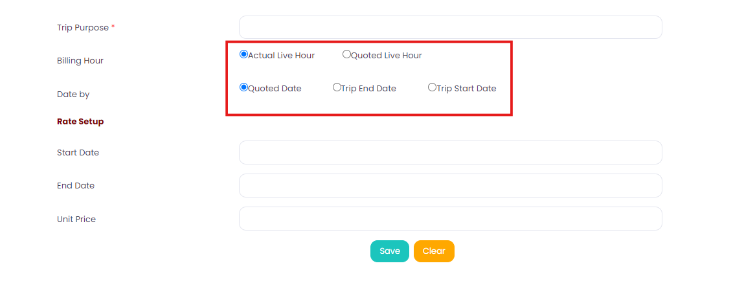

1. Setup-Fuel surcharge setup-Click Add new- After click clear button, Trip purpose is not getting cleared. And Also, Billing hour and Date by radio button doesnot change to default values.

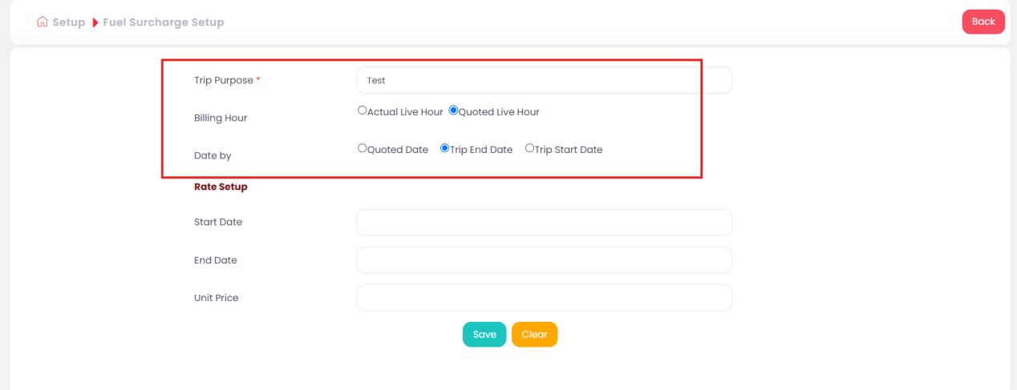

1. Setup-Fuel surcharge setup-Click Add new-Duplicate values also accepted (which means existing data entered in all fields data gets saved), but page should not accept existing data details.

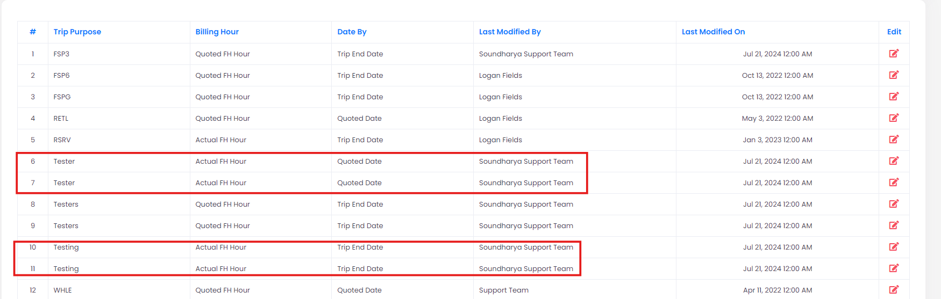

1. Setup-GL Code Setup- Company have “ALL” option, Entery status have “ALL” option, GP Upload Flag have “ALL” option and status have inactive option and click search button, page navigates to ADD NEW Page.
2. Setup-GL Code Setup-Add new-Clear button is not working.
3. Setup-Price Setup-After click Price Setup button in menu, but page show Rate Setup. Need to change the topic Rate Setup to Price Setup.

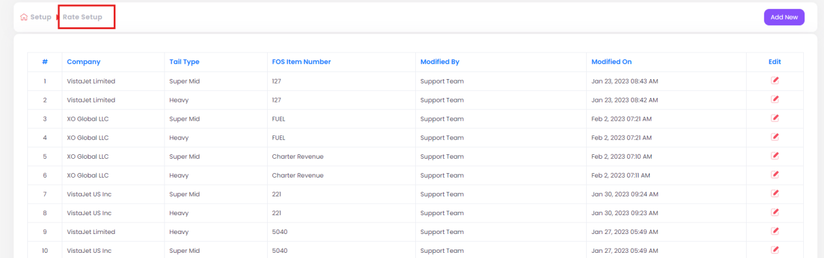

1. Setup-Exclude line item-Add new/Edit page, clear button is not working.
2. Setup-NS Customer-Add new/Edit page, clear button is not working.
3. Setup-Rate Setup-Add new/Edit page, after click clear button, billing hour radio button is not moves to default value.
4. Setup-Rate Setup-Add new/Edit page, clear button is not working.
5. Setup-Company Setup-Add new/Edit page, clear button is not working.
6. Setup-Company GL Setup-Add new/Edit page, clear button is not working.
7. Setup-Fuel Surcharge Setup-Add new/Edit page,after click clear button, trip purpose field is not getting cleared. And also, billing hour and Date by radio button is not change to deffault values.
8. Setup-GL Code Setup-Add new/Edit page, clear button is not working.
9. FOS File Upload-FOS Upload 1.0- After select valid from and to date, then click clear button data field gets cleared. But again try to click the from and to calendar tab, calendar wont open.
10. FOS File Upload-FOS Upload 2.0- After select valid from and to date, then click clear button data field gets cleared. But again try to click the from and to calendar tab, calendar wont open.
11. FOS File Upload-**Off-Fleet Upload**- After select valid from and to date, then click clear button data field gets cleared. But again try to click the from and to calendar tab, calendar wont open.

30.Setup-Fuel Surcharge Setup-When enter Start date is greater than end date, date gets accepted without any issues.

